Hi Ladislau,

The first attempt failed again.

Finally, success after performing the following steps:

1. npm install -g <https://dezyne.verum.com/download/npm/dzn-2.9.1.tar.gz>

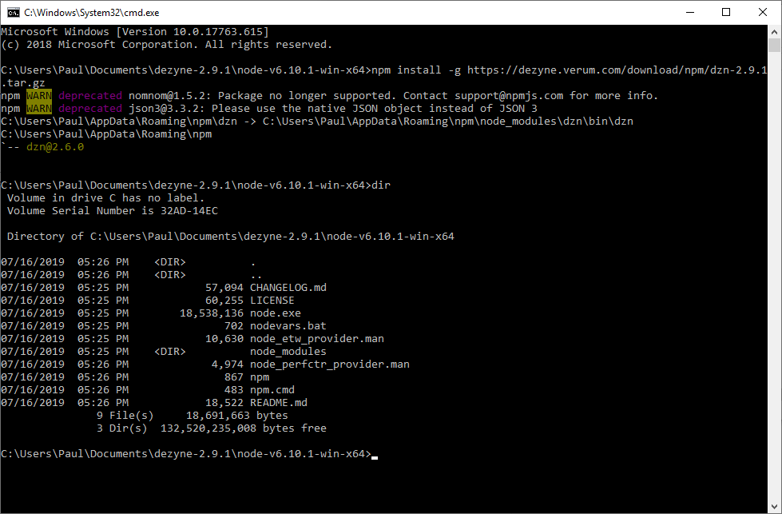

The dzn files were copied to Roaming\npm\node_modules\dzn\bin\dzn.

But not to dezyne-2.9.1\node-v6.10.1-win-x64 as you can see on the screenshot above!

2. So I copied the dzn files manually to: C:\Users\Paul\Documents\dezyne-2.9.1\node-v6.10.1-win-x64

Now I could start Dezyne and it worked!

Strange that I had to do this last step manually! Why?

So now I tried again with the following command (first removed the just copied dzn files):

C:\Users\Paul\Documents\dezyne-2.9.1\node-v6.10.1-win-x64>.\npm install -g <https://dezyne.verum.com/download/npm/dzn-2.9.1.tar.gz>

npm WARN deprecated [nomnom@1.5.2](mailto:nomnom@1.5.2): Package no longer supported. Contact [support@npmjs.com](mailto:support@npmjs.com) for more info.

npm WARN deprecated [json3@3.3.2](mailto:json3@3.3.2): Please use the native JSON object instead of JSON 3

C:\Users\Paul\AppData\Roaming\npm\dzn -> C:\Users\Paul\AppData\Roaming\npm\node_modules\dzn\bin\dzn

C:\Users\Paul\AppData\Roaming\npm

`-- [dzn@2.6.0](mailto:dzn@2.6.0)

So, I think what happened is this: another version of npm was run in the first place (found in PATH).

By putting “.\” in front of npm, the npm from node-v6.10.1-win-x64 was used this time.

So, Windows is always looking in the PATH before scanning the current directory. Nice feature☹

Maybe this can “.\” can be added in the Dezyne installation script for the next time?

I am glad that it works now.

Thanks for your help!

Regards,

Paul

**Van:** Verum HelpDesk <[helpdesk@verum.com](mailto:helpdesk@verum.com)>   
**Verzonden:** Tuesday, July 16, 2019 5:12 PM  
**Aan:** Paul Langemeijer <[paullangemeijer@hotmail.com](mailto:paullangemeijer@hotmail.com)>  
**CC:** [helpdesk@verum.com](mailto:helpdesk@verum.com)  
**Onderwerp:** Re:[## 7558 ##] Cannot install Dezyne

Hi,

The difference in the Email between the Preferences dialog window and the Problem occurred dialog also shows that there are some pending node.exe tasks which are not ended or something strange happens on your system. I don't have an explanation on how '[paullangemeijer@hotmail.com](mailto:paullangemeijer@hotmail.com)' is transformed to '[PaulLangemeijer@hotmail.com](mailto:PaulLangemeijer@hotmail.com)'

Best regards,

Ladislau Posta

---- On Tue, 16 Jul 2019 17:05:39 +0200**"Verum HelpDesk"<**[**helpdesk@verum.com**](mailto:helpdesk@verum.com)**>** wrote ----

Hi,

I am sorry to hear this.

Please follow the next steps:

1. End all node.exe tasks using the TaskManager

2. Remove the 'C:\Users\Paul\Documents\dezyne+jre-win32.x86_64-2.9.1.r' folder

3. Remove the .dzn.json file from ' C:\Users\Paul'

4. Remove 'dzn' and 'dzn-daemon' folders from 'C:\Users\Paul\AppData\Roaming\npm\node_modules'

5. Execute the steps I have sent before, please specify 'dezyne-2.9.1' instead of 'dezyne+jre-win32.x86_64-2.9.1.r' as folder name

If this is also not successful please try the following from a command prompt:

'C:\Users\Paul\Documents\dezyne-2.9.1\node-v6.10.1-win-x64\npm install -g [https://dezyne.verum.com/download/npm/dzn-2.9.1.tar.gz](https://eur04.safelinks.protection.outlook.com/?url=https%3A%2F%2Fdezyne.verum.com%2Fdownload%2Fnpm%2Fdzn-2.9.1.tar.gz&data=02%7C01%7C%7C7030b934f6864c2de08c08d709fffc71%7C84df9e7fe9f640afb435aaaaaaaaaaaa%7C1%7C0%7C636988867379860088&sdata=Sin4eDWQGXx0cwIfBCR7qAlly%2FcwGGdwlnrH60CVKgI%3D&reserved=0)'

or the following also from the command prompt after you have changed the directory to 'C:\Users\Paul\Documents\dezyne-2.9.1\node-v6.10.1-win-x64':

'npm install -g [https://dezyne.verum.com/download/npm/dzn-2.9.1.tar.gz](https://eur04.safelinks.protection.outlook.com/?url=https%3A%2F%2Fdezyne.verum.com%2Fdownload%2Fnpm%2Fdzn-2.9.1.tar.gz&data=02%7C01%7C%7C7030b934f6864c2de08c08d709fffc71%7C84df9e7fe9f640afb435aaaaaaaaaaaa%7C1%7C0%7C636988867379870087&sdata=LOrh8pBqgVLbb5jl3C%2Ba7MiUeK82zZNJuvFgHoTBPxc%3D&reserved=0)'

If needed we can consider a remote desktop session using TeamViewer or Zoom.

Best regards,

Ladislau Posta

---- On Tue, 16 Jul 2019 16:33:14 +0200**"Paul Langemeijer"<**[**paullangemeijer@hotmail.com**](mailto:paullangemeijer@hotmail.com)**>** wrote ----

Hi,

Unfortunately, the proposed procedure did not help me.

I filled in:

After restarting Dezyne, this is what I saw:

I click on OK

I click on OK

And:

And:

dzn$ dzn --server=[https://dezyne.verum.com/service/2.9](https://eur04.safelinks.protection.outlook.com/?url=https%3A%2F%2Fdezyne.verum.com%2Fservice%2F2.9&data=02%7C01%7C%7C7030b934f6864c2de08c08d709fffc71%7C84df9e7fe9f640afb435aaaaaaaaaaaa%7C1%7C0%7C636988867379880100&sdata=RDR6gWpmQceOJitRGFUJ6BaFNorF%2FTmOgHwOzRJ45tY%3D&reserved=0) --user=[PaulLangemeijer@hotmail.com](mailto:PaulLangemeijer@hotmail.com) -p hello

'C:\Users\Paul\Documents\dezyne+jre-win32.x86_64-2.9.1.r\node-v6.10.1-win-x64\dzn' is not recognized as an internal or external command,

operable program or batch file.

Exit Code: 1

dzn$ npm install -g C:\Users\Paul\AppData\Local\Temp\dzn-2.9.1.tar.gz

working directory: C:\Users\Paul\Documents\dezyne+jre-win32.x86_64-2.9.1.r\workspace

npm

WARN deprecated [nomnom@1.5.2](mailto:nomnom@1.5.2): Package no longer supported. Contact [support@npmjs.com](mailto:support@npmjs.com) for more info.

npm WARN

deprecated [json3@3.3.2](mailto:json3@3.3.2): Please use the native JSON object instead of JSON 3

C:\Users\Paul\AppData\Roaming\npm\dzn -> C:\Users\Paul\AppData\Roaming\npm\node_modules\dzn\bin\dzn

C:\Users\Paul\AppData\Roaming\npm

`-- [dzn@2.6.0](mailto:dzn@2.6.0)

dzn$

As you can see in the next picture, dzn was not copied. But why?

Tried it several times….

Regards,

Paul

**Van:** Verum HelpDesk <[helpdesk@verum.com](mailto:helpdesk@verum.com)>   
**Verzonden:** Tuesday, July 16, 2019 3:48 PM  
**Aan:** Paul Langemeijer <[paullangemeijer@hotmail.com](mailto:paullangemeijer@hotmail.com)>  
**CC:** [helpdesk@verum.com](mailto:helpdesk@verum.com)  
**Onderwerp:** Re:[## 7558 ##] Cannot install Dezyne

Hi,

From what you sent it seems that you have a dzn-2.6.0 installed on your system.

In order to properly install Dezyne 2.9.1 please follow the next steps:

•         download and unpack Dezyne

•         create a 'workspace' folder in the directory where you have unpacked Dezyne

•         start Dezyne and select the newly created directory as workspace

•         press 'Cancel' (when indicated that Node.js and dzn needs to be installed)

•         enter your Dezyne credentials and type "[https://dezyne.verum.com/service/2.9](https://eur04.safelinks.protection.outlook.com/?url=https%3A%2F%2Fdezyne.verum.com%2Fservice%2F2.9&data=02%7C01%7C%7C7030b934f6864c2de08c08d709fffc71%7C84df9e7fe9f640afb435aaaaaaaaaaaa%7C1%7C0%7C636988867379880100&sdata=RDR6gWpmQceOJitRGFUJ6BaFNorF%2FTmOgHwOzRJ45tY%3D&reserved=0)" as 'Server URI' instead of "[https://hosting.verum.com](https://eur04.safelinks.protection.outlook.com/?url=https%3A%2F%2Fhosting.verum.com%2F&data=02%7C01%7C%7C7030b934f6864c2de08c08d709fffc71%7C84df9e7fe9f640afb435aaaaaaaaaaaa%7C1%7C0%7C636988867379890108&sdata=tmryDD3SHlsFgY0rccfWRbLiL%2BzNYE5Lj0ZSi%2BN4tGo%3D&reserved=0)" in the Preferences dialog window (select the Window-Preferences menu item and click on Dezyne)

•         press 'Apply and Close' and wait until authentication fails

•         press OK and close Dezyne

•         re-start Dezyne

•         install Node.js and dzn-2.9.1 in a folder of your choice

Please ensure that there are no node.exe tasks running.

I hope this will work for you.

Best regards,

Ladislau Posta

---- On Tue, 16 Jul 2019 15:37:56 +0200**"Paul Langemeijer"<**[**paullangemeijer@hotmail.com**](mailto:paullangemeijer@hotmail.com)**>** wrote ----

Hi Ladislau,

 Dezyne was copied to: C:\Users\Paul\Documents\dezyne+jre-win32.x86_64-2.9.1.r

In fact the same folder as on my laptop.

What I also see in Eclipse is this:

dzn$ npm install -g C:\Users\Paul\AppData\Local\Temp\dzn-2.8.0.tar.gz

working directory: C:\Users\Paul\Documents\dezyne+jre-win32.x86_64-2.9.1.r\workspace

C:\Users\Paul\AppData\Roaming\npm\dzn -> C:\Users\Paul\AppData\Roaming\npm\node_modules\dzn\bin\dzn

C:\Users\Paul\AppData\Roaming\npm

`-- [dzn@2.6.0](https://eur04.safelinks.protection.outlook.com/?url=http%3A%2F%2Fmailto%3Adzn%402.6.0.0%2F&data=02%7C01%7C%7C7030b934f6864c2de08c08d709fffc71%7C84df9e7fe9f640afb435aaaaaaaaaaaa%7C1%7C0%7C636988867379900121&sdata=Dw5VOqSP4NE85nFMU3Q0c6EtGI2xroi6nhEuYSZH1zM%3D&reserved=0)

dzn$

I think that the contents of “C:\Users\Paul\AppData\Roaming” should have been copied to the node-v6.10.1-win-x64 folder, but that does not happen.

Regards,

Paul

**Van:** Verum HelpDesk <[helpdesk@verum.com](mailto:helpdesk@verum.com)>  
**Verzonden:** Tuesday, July 16, 2019 3:24:02 PM  
**Aan:** [paullangemeijer@hotmail.com](mailto:paullangemeijer@hotmail.com)  
**CC:** [helpdesk@verum.com](mailto:helpdesk@verum.com); Verum Support Team  
**Onderwerp:** Re:[## 7558 ##] Cannot install Dezyne

Dear Paul Langemeijer,

I am sorry to hear that you are experiencing installation problems.

From what you have listed it seems that you experience problems in installing dzn. This is an automated process when you start Dezyne.

At first sight may I ask you to let us know what the path to your 'My Documents' folder is, i.e. the path where you have unpacked Dezyne to.

Thanks a lot for your understanding, for your patience and for your interest in Dezyne.

Best regards,

Ladislau Posta

---- On Tue, 16 Jul 2019 15:14:27 +0200[**paullangemeijer@hotmail.com**](mailto:paullangemeijer@hotmail.com) wrote ----

I have tried to get Dezyne working for hours now, but without success. I am really desperate now. This is what I have done so far:

Note: I have been using Dezyne successfully on my Windows PC in the past.

- Login and download latest version of Dezyne

- unpacked and copied zip file to my documents folder

- started Dezyne

- I get a popup to install node and dzn. I click on OK.

- I see popup: 'dzn' command  line successfully installed.

This is however not true: in folder node-v6.10.1-win-x64 the following files are missing:

dzn, dzn.cmd and etc folder ( I checked this with a succesfull installation on my laptop).

So I get a popup to install node and dzn again and again.

- I repeated the installation over and over again.

There is no folder "node-v6.10.1-win-x64" in my home folder.

There does exist a version of npm on my system. I am anxious to remove that version because other programs may not work anymore.

There is no **dzn.daemon.log** on my PC. No .cache folder in my HOME directory.

Reinstalling my PC would take even a lot of time.

So what can I do more?